**ASSIGNMENT 4**

Submitted by: Akshay Jain

Registration Number: 17BCS002

**Topic:** LIFE INSURANCE

**Problem 1**

**SCHEMA AND TABLE VIEW**

Table 1: Accident

* **Schema:**

CREATE TABLE Accident(

date DATE NOT NULL,

report_id INTEGER PRIMARY KEY AUTOINCREMENT,

police_report_doc IMAGE NOT NULL,

damage_cost FLOAT NOT NULL,

fault BOOLEAN NOT NULL,

customer_id INTEGER,

CONSTRAINT fk_customer

FOREIGN KEY (customer_id)

REFERENCES Customer(customer_id)

ON DELETE CASCADE

)

* **View:**

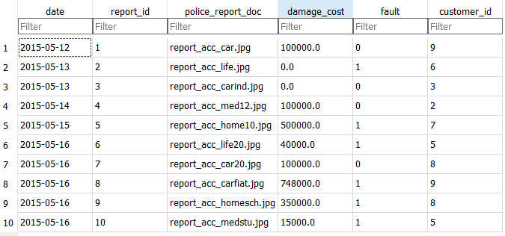

Table 2: Address

* **Schema:**

CREATE TABLE "Address" (

"state" TEXT NOT NULL,

"city" TEXT NOT NULL,

"pincode" INTEGER NOT NULL,

PRIMARY KEY("pincode")

)

* **View:**

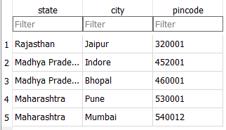

Table 3: Agent

* **Schema:**

CREATE TABLE Agent (

"agent_id" INTEGER PRIMARY KEY AUTOINCREMENT,

"first_name" TEXT NOT NULL,

"last_name" TEXT NOT NULL,

"user_name" VARCHAR NOT NULL UNIQUE,

"date_of_birth" date NOT NULL,

"aadhar_number" VARCHAR NOT NULL UNIQUE,

"contact_details" VARCHAR NOT NULL,

"pincode" INTEGER,

CONSTRAINT fk_address

FOREIGN KEY (pincode)

REFERENCES Address(pincode)

ON DELETE CASCADE

)

* **View:**

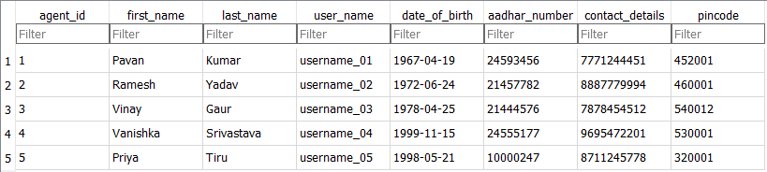

Table 4: Customer

* **Schema:**

CREATE TABLE Customer(

customer_id INTEGER PRIMARY KEY AUTOINCREMENT,

first_name TEXT NOT NULL,

last_name TEXT NOT NULL,

aadhar_number VARCHAR UNIQUE NOT NULL,

date_of_birth DATE NOT NULL,

driving_license_number VARCHAR NOT NULL,

contact_details VARCHAR NOT NULL,

pincode INTEGER,

agent_id INTEGER,

policy_number INTEGER,

CONSTRAINT fk_address

FOREIGN KEY (pincode)

REFERENCES Address(pincode)

ON DELETE CASCADE,

CONSTRAINT fk_agent

FOREIGN KEY (agent_id)

REFERENCES Agent(agent_id)

ON DELETE CASCADE,

CONSTRAINT fk_policy

FOREIGN KEY (policy_number)

REFERENCES "_old"(policy_number)

ON DELETE CASCADE

)

* **View:**

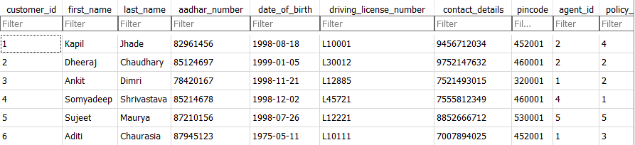

Table 5: Insurance

* **Schema:**

CREATE TABLE "Insurance" (

"insurance_id" INTEGER NOT NULL PRIMARY KEY AUTOINCREMENT UNIQUE,

"insurance_type" VARCHAR NOT NULL

)

* **View:**

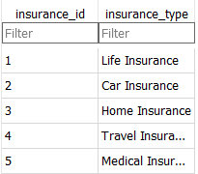

Table 6: Payment

* **Schema:**

CREATE TABLE Payment(

transaction_id INTEGER PRIMARY KEY,

date_of_payment DATE NOT NULL,

payment_amount FLOAT NOT NULL,

report_id INTEGER,

CONSTRAINT fk_accident

FOREIGN KEY (report_id)

REFERENCES "_old"(report_id)

ON DELETE CASCADE

)

* **View:**

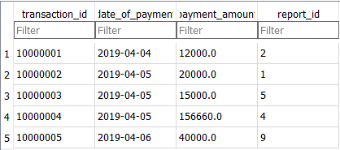

Table 7: Policy

* **Schema:**

CREATE TABLE Policy(

policy_number INTEGER PRIMARY KEY AUTOINCREMENT,

issue_date DATE NOT NULL,

term_cost FLOAT NOT NULL,

amount_coverage FLOAT NOT NULL,

policy_type VARCHAR NOT NULL,

insurance_id INTEGER,

CONSTRAINT fk_insurance

FOREIGN KEY (insurance_id)

REFERENCES Insurance(insurance_id)

ON DELETE CASCADE

)

* **View:**

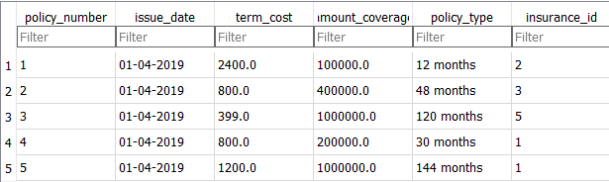

**Problem 2**

**Solution 2.1:**

Query:

SELECT

transaction_id, date_of_payment, Accident.customer_id

FROM

Accident, Payment

WHERE

Accident.report_id = Payment.report_id

View:

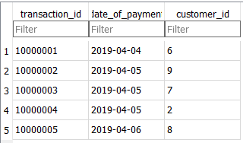

**Solution 2.2:**

Query:

SELECT

first_name || "(" || "testing" || ")" AS newcolumn

FROM

Customer

View:

